**Group 109**

**USCoffee Software Development Plan**

**Version <1.0>**

[Note: The following template is provided for use with the Rational Unified Process. Text enclosed in square brackets and displayed in blue italics (style=InfoBlue) is included to provide guidance to the author and should be deleted before publishing the document. A paragraph entered following this style will automatically be set to normal (style=Body Text).]

[To customize automatic fields in Microsoft Word (which display a gray background when selected), select File>Properties and replace the Title, Subject and Company fields with the appropriate information for this document. After closing the dialog, automatic fields may be updated throughout the document by selecting Edit>Select All (or Ctrl-A) and pressing F9, or simply click on the field and press F9. This must be done separately for Headers and Footers. Alt-F9 will toggle between displaying the field names and the field contents. See Word help for more information on working with fields.]

**Revision History**

|  |  |  |  |
| --- | --- | --- | --- |
| **Date** | **Version** | **Description** | **Author** |
| 24/06/2023 | <1.0> | First version of the project plan | <name> |
|  |  |  |  |
|  |  |  |  |
|  |  |  |  |

**Table of Contents**

1. Introduction 4
2. Project Overview 4
   1. Project Purpose, Scope, and Objectives 4
   2. Assumptions and Constraintts 4
   3. Project Deliverables 4
3. Project Organization 5
   1. Organizational Structure 5
   2. Roles and Responsibilities 5
4. Management Process 5
   1. Project Estimates 5
   2. Project Plan 5
      1. Phase and Iteration Plan 5
      2. Releases 7
   3. Project Monitoring and Control 7
      1. Reporting 7
      2. Risk Management 7
      3. Configuration Management 7

**Software Development Plan**

# Introduction

Software Development Plan provides an overview of the entire document. It includes the purpose, scope, definitions. Acronyms, abbreviations, references, and overview of this Software Development Plan

# Project Overview

## Project Purpose, Scope, and Objectives

The purpose of this project is to develop a website for selling coffee products online. The website will provide customers with a user-friendly interface to browse and purchase a variety of coffee products. The key objectives of the project are as follows:

* + - Design and develop an attractive and responsive website that showcases different coffee products and their descriptions.
    - Create a user registration and login system to personalize the shopping experience and enable order tracking.
    - Incorporate a search functionality to allow customers to easily find specific coffee products based on various criteria such as type, flavor, or origin.
    - Complete the project within the allocated time frame and budget.

## Assumptions and Constraintts

Assumptions:

* + - The project team will have access to the necessary hardware, software, and development tools.
    - The content and images for the coffee products will be provided by the client.
    - Project has 4 people, there will be no more people added during the project.
    - The website will be developed using a specific programming language and framework as determined by the project team.

Constraints:

* + - The project budget is limited and should be carefully managed.
    - The development team will consist of 2 developers and 2 designers.
    - The website should be compatible with the client's existing backend structure.

## Project Deliverables

The following deliverables are expected upon the completion of the project:

* + - Enough functional and responsive website for selling coffee products.
    - User registration and login system with personalized user profiles.
    - Administration panel for managing product inventory and orders.

# Project Organization

## Organizational Structure

Designer, BA assistant: Nguyen Hoang Duc Nguyen

Developer assitant: Nguyen Dac Khoi

Tester: Nguyen Hoang Duc Nguyen

Designer, BA: Duong Phuoc Sang

Architecture, Developer: Tran Van Quyet,

Team Lead, PM: Nguyen Dac Khoi

## Roles and Responsibilities

|  |  |
| --- | --- |
| **Person** | **Role** |
| Nguyen Dac Khoi Tran Van Quyet Duong Phuoc Sang  Nguyen Hoang Duc Nguyen | Project Manager, Developer (member) Architecture, Developer (leader) Designer (leader), BA (leader)  Tester, Designer (member), BA (member) |

# Management Process

## Project Estimates

## Project Plan

* + 1. *Phase and Iteration Plan*

Phase and Iteration Plan

The project consists of 4 phases: Inception, Elaboration and Construction, Transition Inception:

* + - * Sprint 1

- Start: 11/06/2023

- End: 24/06/2023

* + - * Task: Research and write the first version of Project Plan and Vision Document, learning how to set up JS in IDE

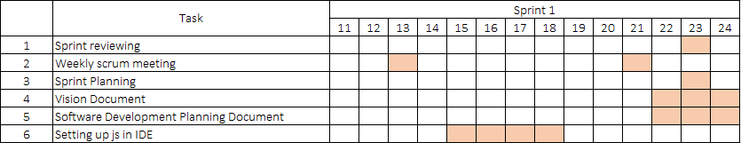

Elaboration:

* + - * Sprint 2 & 3

- Start: 25/06/2023

- End: 22/07/2023

* + - * Task:

+ Modify, fix the issues, revised project plan follows TA’s opinion.

+ Use-case document and use-case model.

+ Define software architecture using class diagram.

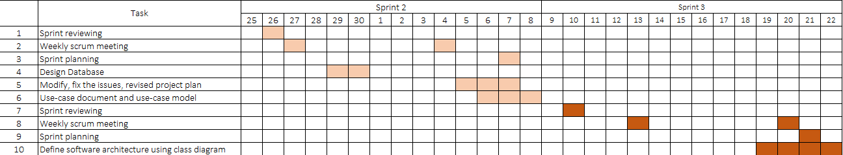

Construction:

* + - * Sprint 4 & 5

- Start: 23/07/2023

- End: 19/08/2023

* + - * Task:

+ Revised version of Software Architecture Document.

+ Sketch user interface for the system by designing UI.

+ Write test plan.

+ Implement and design test cases.

+ Release the first version of project.

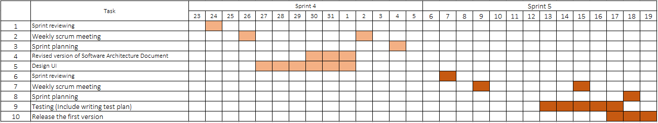

Transition:

* + - * Sprint 6

- Start: 20/08/2023

- End: 02/09/2023

* + - * Task:

+ Jot down test summary report.

+ Implement automated testing.

+ Release the final version of the product.

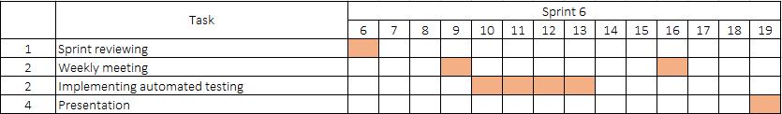+ Project presentation.

**Note:** This plan is temporarily missing the program implementation because we couldn’t be sure what features, what function we will code in each phase. We apologize for omission and we will add as soon as possible.

* + 1. *Releases*

There will be 2 versions to be released:

* + - * The first version will be released during the process of doing PA5.
      * The final version will be released in the presentation of PA6.

## Project Monitoring and Control

* + 1. *Reporting*
       - For discussing, reporting tasks among members, we use Discord and Messenger
       - We use Facebook for asking TAs some questions related to project.
       - We use Trello for planning and assigning tasks for members.
    2. *Risk Management*

*[Identify risks in your project. The risks should be prioritized, and shorted according to their priority.]*

|  |  |  |  |  |  |
| --- | --- | --- | --- | --- | --- |
| *Risk ID* | *Risk Description* | *Probability* | *Impact* | *Priority* | *Mitigation Strategy or Contingency Plan* |
|  |  |  |  |  |  |
|  |  |  |  |  |  |
|  |  |  |  |  |  |

* + 1. *Configuration Management*
* For storing documents and project reports, we use Google Drive follow instructions of TAs.
* For managing source code and related files, we use GitHub.
* And discord is also used as a place to store code, ideas, …